Exercise 3

# Geocoding csv file using ArcGIS Enterprise geocoder

First, review the address data in Incidents_address.csv (<https://github.com/CathyW16/ArcGIS-Enterprise-Workshop/blob/main/data/Incidents_address.csv> ).

From the file, we can see that it contains five fields. The first four provide the street, city, state, and postal code, while the last field contains the full address.

Open ArcGIS Pro. Ensure the current active portal is ArcGIS Enterprise.

Under the Analysis tab, click Tools.

In the Geoprocessing panel, type 'geocoding' in the search box and select Geocode Addresses.

In Input Table, select incidents_address.csv.

For Input Address Locator, open the browser, expand Portal in the left panel, click My Organization, and select AGO World Geocoder (Harvard_CGA).

Now we configure the parameters for the geocoding:

* Input Address Fields: This maps the address fields used by the address locator. Select Single Field if the complete address is stored in one field in the input table. Select Multiple Fields if the input addresses are divided into multiple fields such as Address, City, State, and ZIP for a general United States address. Select Single Field and Country Field if the complete address and the country are split into separate fields.

* Output Feature Class: Saving the output in shapefile format is not supported.

* Country (Optional): The country or countries where the geocoded addresses will be searched. This is limited to the specified country or countries. If no country is specified, geocoding is performed using all supported countries of the locator.

* Preferred Location Type (Optional)
  + Address location— Geometry for geocode results representing an address location (e.g., rooftop location, parcel centroid, or front door) will be returned.
  + Routing location— Geometry for geocode results representing a location near the street, useful for vehicle routing, will be returned (this is the default).

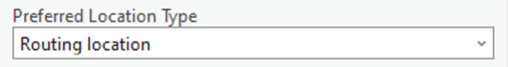

* Category (Optional)：Limits the types of places the locator searches. When no category is used, geocoding is performed using all supported categories.

* Output Fields (Optional)：
  + All—Includes all available locator output fields in the geocode results (default).
  + Location Only—Stores the Shape field in the geocode results, maintaining the original field names from the input table.
  + Minimal—Adds fields describing the location and how well it matches the locator information: Shape, Status, Score, Match_type, Match_addr, and Addr_type, while keeping the original field names.
  + Minimal and User Fields—Adds the same fields as 'Minimal' and any user-defined custom output fields.

Finally, we need to click Estimate Credits. However, since we are using a locator available on ArcGIS Enterprise, no credits will be consumed. This is just a necessary step in the process.

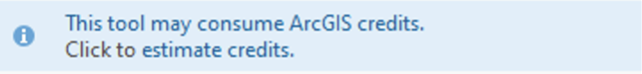

Click Run.

The resulting point data will be automatically added to the map after geocoding.

You can open the Incidents attribute table to view the geocoding results.

**X, Y**:

* **X**: The X coordinate (usually longitude or the horizontal coordinate) of the matched address or location in a coordinate system.
* **Y**: The Y coordinate (usually latitude or the vertical coordinate).
* These generally represent the **street-level coordinates**, used for route planning (e.g., where the location is along the street).

**DisplayX, DisplayY**:

* **DisplayX**: The X coordinate representing the display position, often the rooftop or centroid of the building or parcel.
* **DisplayY**: The Y coordinate corresponding to the display position, indicating the center of the actual location. These values are best used for displaying the precise location rather than routing.

**Xmin, Ymin, Xmax, Ymax**:

* **Xmin**: The minimum X coordinate (usually the left boundary) of the bounding box that surrounds the address or location.
* **Ymin**: The minimum Y coordinate (the bottom boundary) of the bounding box.
* **Xmax**: The maximum X coordinate (the right boundary) of the bounding box.
* **Ymax**: The maximum Y coordinate (the top boundary) of the bounding box.

More info on geocoded results:

<https://pro.arcgis.com/en/pro-app/latest/help/data/geocoding/what-is-included-in-the-geocoded-results-.htm>